**Project Planning Phase**

**Project Planning Template (Product Backlog, Sprint Planning, Stories, Story points)**

|  |  |
| --- | --- |
| Date | 28-10-2022 |
| Team ID | PNT2022TMID14620 |
| Project Name | Project - Deep Learning Fundus Image Analysis for Early Detection of Diabetic Retinopathy |
| Maximum Marks | 8 Marks |

**Product Backlog, Sprint Schedule, and Estimation (4 Marks)**

Use the below template to create product backlog and sprint schedule

| **Sprint** | **Functional Requirement (Epic)** | **User Story Number** | **User Story / Task** | **Story Points** | **Priority** | **Team Members** |
| --- | --- | --- | --- | --- | --- | --- |
| Sprint-1 | Home/Index page | USN-1 | As a user, I should be able to view the landing page provided with login, register options into the portal | 5 | Medium |  |
| Sprint-1 | Register | USN-2 | As a user, I can register for the application by entering my email, password, and confirming my password. | 5 | High |  |
|  |  | USN-3 | As a user, I will receive confirmation email once I have registered for the application | 3 | Low |  |
| Sprint-2 | Login | USN-4 | As a user, I can log into the application by entering email & password | 5 | Medium |  |
| Sprint-2 | Dashboard | USN-5 | As a user, I should be able to upload images and provided with an option to predict the uploaded image | 5 | High |  |
|  |  | USN-6 | As a user, I should be able to logout from the dash board | 3 | Low |  |

**Project Tracker, Velocity & Burndown Chart: (4 Marks)**

| **Sprint** | **Total Story Points** | **Duration** | **Sprint Start Date** | **Sprint End Date (Planned)** | **Story Points Completed (as on Planned End Date)** | **Sprint Release Date (Actual)** |
| --- | --- | --- | --- | --- | --- | --- |
| Sprint-1 | 13 | 6 Days | 28 Oct 2022 | 03 Nov 2022 | 13 | 03 Nov 2022 |
| Sprint-2 | 13 | 6 Days | 04 Nov 2022 | 10 Nov 2022 |  |  |

**Velocity:**



AV = 6/13=0.46

**Burndown Chart:**

A burn down chart is a graphical representation of work left to do versus time. It is often used in agile[software development](https://www.visual-paradigm.com/scrum/what-is-agile-software-development/) methodologies such as [Scrum](https://www.visual-paradigm.com/scrum/scrum-in-3-minutes/). However, burn down charts can be applied to any project containing measurable progress over time.

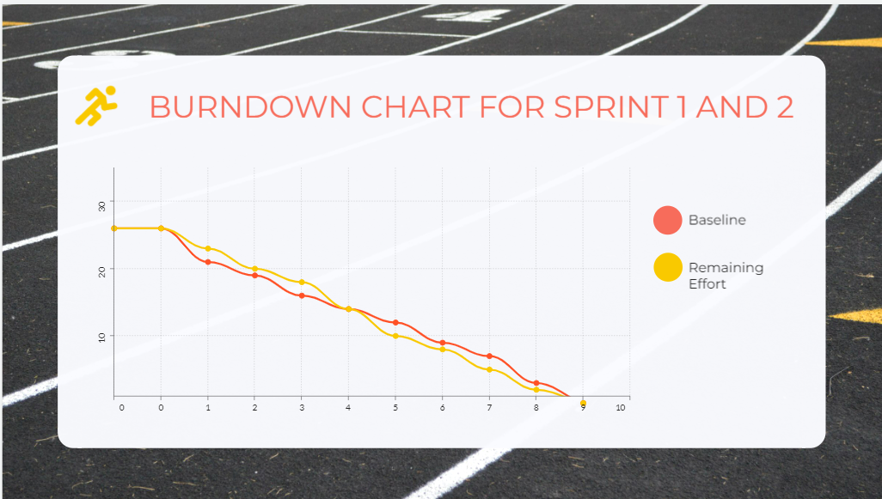

**Reference:**

[**https://www.atlassian.com/agile/project-management**](https://www.atlassian.com/agile/project-management)

[**https://www.atlassian.com/agile/tutorials/how-to-do-scrum-with-jira-software**](https://www.atlassian.com/agile/tutorials/how-to-do-scrum-with-jira-software)

[**https://www.atlassian.com/agile/tutorials/epics**](https://www.atlassian.com/agile/tutorials/epics)

[**https://www.atlassian.com/agile/tutorials/sprints**](https://www.atlassian.com/agile/tutorials/sprints)

[**https://www.atlassian.com/agile/project-management/estimation**](https://www.atlassian.com/agile/project-management/estimation)

[**https://www.atlassian.com/agile/tutorials/burndown-charts**](https://www.atlassian.com/agile/tutorials/burndown-charts)